# [LAW & ORDER Crossover Event Recap: ‘Gimme Shelter’ Sets Up a Big SVU Storyline](https://www.givememyremote.com/remote/2022/09/22/law-and-order-crossover-recap-rollins-shot/)

September 22, 2022 by [Marisa Roffman](https://www.givememyremote.com/remote/author/marisa/)

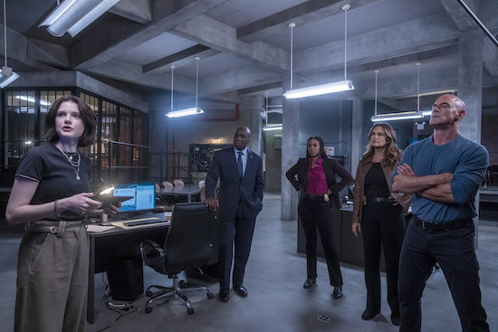

***LAW & ORDER: SPECIAL VICTIMS UNIT — “Gimme Shelter” Episode 24003 — Pictured: (l-r) — (Photo by: Zach Dilgard/NBC)***

**[Warning: This post contains spoilers for the LAW & ORDER crossover event.]**

The LAW & ORDER franchise came together for its biggest crossover yet with the season-opening [“Gimme Shelter”](https://www.givememyremote.com/remote/2022/09/20/law-order-crossover-event-gimme-shelter-photos/)—and laid the groundwork for LAW & ORDER: SPECIAL VICTIMS UNIT season 24.

After a young girl, Ava, was killed in front of him, LAW & ORDER’s Detective Cosgrove ([Jeffrey Donovan](https://www.givememyremote.com/remote/2021/11/01/law-and-order-jeffrey-donovan-cast-season-21/)) paired up with Detective Shaw ([Mehcad Brooks](https://www.givememyremote.com/remote/2022/08/26/law-and-order-detective-jalen-shaw-mehcad-brooks-rick-eid/)) to figure out who killed her. But when they realized Mark Sirenko (Beau Knapp) might be involved, it put the duo on a collision course with ORGANIZED CRIME’s Detective Stabler ([Christopher Meloni](https://www.givememyremote.com/remote/2021/06/04/svu-organized-crime-benson-stabler-romance-mariska-hargitay-christopher-meloni/)), who told Cosgrove OCCB had been working him for six months.

Cosgrove convinced Stabler—thanks to a little bit of emotional blackmail—to help take down Sirenko for this murder. Stabler asked his CI, Vince (Andrew Yackel) who had been embedded getting information on Sirenko’s drug running, to clone Mark’s phone.

Using the footage, Stabler and Cosgrove found proof Sirenko had been trafficking girls, and there was a female pimp working with him. Stabler brought the video to SVU’s Captain Benson ([Mariska Hargitay](https://www.givememyremote.com/remote/2021/04/02/mariska-hargitay-christopher-meloni-elliot-olivia-reunion-svu-organized-crime/))—who had helped earlier by advising about alternate boat dock footage—and she got her squad to track down Sam (Stephanie Gunn), AKA the Mother Hen.

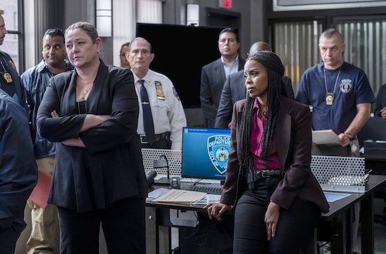

***LAW & ORDER: PREMIERE — “Gimme Shelter” — Episode 24003 — Pictured: (l-r) Camryn Manheim as Lieutenant Kate Dixon, Danielle Moné Truitt as Sergeant Ayanna Bell — (Photo by: Zach Dilgard/NBC)***

The teams arrested Sam, and found a young girl, Nicole (Jaci Calderon), who was able to help Benson with information about Ava’s final hours. As all three squads moved in on Sirenko, Benson, Stabler, and Cosgrove stumbled on materials to build a bomb. Unfortunately for them, they got there too late and the bomb was gone….and Sirenko was on the move with it.

With no leads about where the bomb was, Stabler went back to Vince—who OC’s Jet ([Ainsley Seiger](https://www.givememyremote.com/remote/2021/05/12/law-and-order-organized-crime-ainsley-seiger-interview-jet-season-1/)) equipped with a hidden camera—to try and get intel. But Sirenko was suspicious, and had Vince go with him into a garment factory…and Vince realized quickly it was a trap. When Jet IDed he was looking at a concrete mixer, Stabler put together it was a hit and frantically tried to save him, alongside Benson and Cosgrove. Stabler, however, wasn’t able to get there in time—Vince was shot, fatally.

After discovering the bomb was allegedly at a hotel, the squads mobilized, trying to evacuate the space; Cosgrove, for his part, spotted Sirenko. (Naturally, he lost him again.) Shaw found the device and initially refused to leave, until he was directly ordered to evacuate by L&O’s Lieutenant Dixon ([Camryn Manheim](https://www.givememyremote.com/remote/2021/12/10/law-order-adds-camryn-manheim/)).

As Cosgrove and Shaw refocused on evacuating people, the former spotted Sirenko—only for the bomb to go off. While Sirenko initially got away, the squads tracked him down to a clothing store, holding hostages. When he tried to run, Stabler apprehended him.

L&O’s ADA Price ([Hugh Dancy](https://www.givememyremote.com/remote/2022/09/15/law-and-order-season-22-spoilers-rick-eid/)) was skeptical about why Sirenko would target the hotel—it was filled with diplomats, not his normal crowd. After realizing Sirenko may have been a pawn, Dixon recruited OCCB to find out more. They found a Russian link, via a man named Rublev, and Price and L&O’s ADA Maroun (Odelya Halevi) opted to try the case between him and Sirenko together.

Unfortunately, when a motion tossed out one of their key pieces of evidence, they needed Nicole to testify. Benson agreed and called Rollins, who was with the young woman. But the safe house wasn’t so secure—it was ambushed and Rollins was shot.

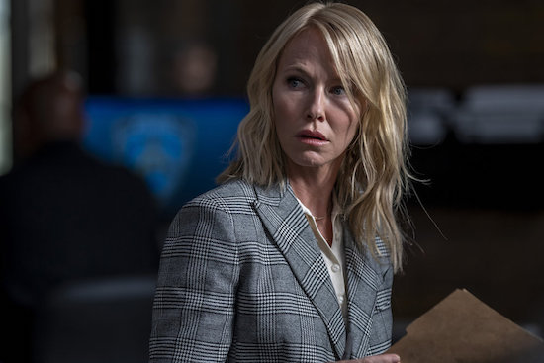

***LAW & ORDER: PREMIERE — “Gimme Shelter” — Pictured: Kelli Giddish as Detective Amanda Rollins — (Photo by: Zach Dilgard/NBC)***

Though the event technically is in its own timeline, the impact of Rollins’ injury will play out in SVU season 24. (Giddish, for her part, [will be exiting the series later this year](https://www.givememyremote.com/remote/2022/08/29/law-and-order-svu-kelli-giddish-final-episode/).)

“We talked about that [with their creative team] to make sure we were all on the same page, and that whatever we set up in the crossover would service what they intended to do for the season,” [“Gimme Shelter” co-writer](https://www.givememyremote.com/remote/2022/09/20/law-and-order-crossover-writer-rick-eid/)—and LAW & ORDER boss—[Rick Eid](https://www.givememyremote.com/remote/2022/09/15/law-and-order-season-22-spoilers-rick-eid/) previously told [Give Me My Remote](https://www.givememyremote.com/remote/).

With Rollins recovering–”Her surgery went well, she’s in stable condition, but hoping for the best,” Benson told Price—the ADAs still needed Nicole to testify. But Benson realized Nicole’s best chance at having a normal life was to get away from it all, and said she found a relative in Toronto to take her in, much to Price’s chagrin.

Backs against the wall, the ADAs realized they had to offer Sirenko a deal to nail Rublev; he took it. (Stabler, for his part, uh, noted his displeasure to Price.) Rublev got worried and offered to turn on Russia, if he got immunity. Price objected to the suggestion and insisted immunity was off the table. Rublev had a counteroffer: he’d answer anything if they saved his family.

Maroun and Price bickered about the right move, but it ended up being a moot point: Rublev was assassinated when he was being transferred.

**What did you think of the crossover?**

**RELATED:**

* [LAW & ORDER Crossover Event: ‘Gimme Shelter’ Photos](https://www.givememyremote.com/remote/2022/09/20/law-order-crossover-event-gimme-shelter-photos/)
* [LAW & ORDER’s Rick Eid on Co-Writing ‘Gimme Shelter’: ‘We Threw Format Out the Window’ for the Franchise-First Crossover](https://www.givememyremote.com/remote/2022/09/20/law-and-order-crossover-writer-rick-eid/)
* [LAW & ORDER Crossover: Watch the Action-Packed First Footage From ‘Gimme Shelter’](https://www.givememyremote.com/remote/2022/09/08/law-order-crossover-promo-gimme-shelter-video/)
* [LAW & ORDER: ORGANIZED CRIME: Bryan Goluboff Exits, Sean Jablonski to Serve as Showrunner](https://www.givememyremote.com/remote/2022/09/01/law-and-order-organized-crime-showrunner-sean-jablonski-bryan-goluboff-exits/)
* [NBC Reveals LAW & ORDER Crossover Key Art](https://www.givememyremote.com/remote/2022/09/01/law-and-order-crossover-poster/)
* [LAW & ORDER: SPECIAL VICTIMS UNIT Boss Reveals Kelli Giddish’s Final Episode](https://www.givememyremote.com/remote/2022/08/29/law-and-order-svu-kelli-giddish-final-episode/)
* [Bryan Goluboff Teases How LAW & ORDER: ORGANIZED CRIME and SVU Will Dive Into Elliot and Olivia’s Time Apart—and Previews Their Future](https://www.givememyremote.com/remote/2022/08/29/organized-crime-elliot-olivia-relationship-svu-bryan-goluboff/)
* [LAW & ORDER’s Rick Eid: Mehcad Brooks’ Detective Shaw ‘Brings a Different Perspective to Law Enforcement’](https://www.givememyremote.com/remote/2022/08/26/law-and-order-detective-jalen-shaw-mehcad-brooks-rick-eid/)
* [LAW & ORDER: SPECIAL VICTIMS UNIT: Kelli Giddish to Exit in Season 24](https://www.givememyremote.com/remote/2022/08/24/law-and-order-svu-kelli-giddish-exit-season-24/)
* [LAW & ORDER: ORGANIZED CRIME is Shaking Up Its Format in Season 3](https://www.givememyremote.com/remote/2022/08/24/law-and-order-organized-crime-season-3-spoilers-bryan-goluboff/)
* [Behind-the-Scenes Photos and Videos from the LAW & ORDER Franchise Crossover](https://www.givememyremote.com/remote/2022/08/24/behind-the-scenes-photos-and-videos-from-the-law-order-franchise-crossover/)
* [NBC Confirms LAW & ORDER Crossover Event With New Promo](https://www.givememyremote.com/remote/2022/08/24/law-and-order-svu-organized-crime-crossover-event/)
* [6 Dream LAW & ORDER Franchise Crossover Pairings](https://www.givememyremote.com/remote/2022/07/14/6-dream-law-and-order-franchise-crossover-pairings/)
* [LAW & ORDER: ORGANIZED CRIME Adds Gus Halper and Camilla Belle](https://www.givememyremote.com/remote/2022/08/12/law-order-organized-crime-gus-halper-camilla-belle/)
* [LAW & ORDER: SPECIAL VICTIMS UNIT Scoop: Molly Burnett to Recur](https://www.givememyremote.com/remote/2022/07/26/law-and-order-svu-molly-burnett-grace-muncy/)
* [LAW & ORDER: ORGANIZED CRIME Adds Rick Gonzalez and Brent Antonello](https://www.givememyremote.com/remote/2022/07/29/law-and-order-organized-crime-season-3-cast-rick-gonzalez-brent-antonello-nona-parker-johnson/)
* [NBC Eyes LAW & ORDER-SVU-ORGANIZED CRIME Crossover Event](https://www.givememyremote.com/remote/2022/07/06/law-and-order-cross-ver-svu-organized-crime-nbc/)
* [LAW & ORDER: SUPERGIRL Vet Mehcad Brooks Joins Season 22](https://www.givememyremote.com/remote/2022/06/13/law-and-order-mehcad-brooks-season-22/)
* [LAW & ORDER: Sam Waterston to Return for Season 22](https://www.givememyremote.com/remote/2022/06/07/law-and-order-season-22-cast-sam-waterston/)
* [LAW & ORDER: SPECIAL VICTIMS UNIT: David Graziano Set as New Showrunner](https://www.givememyremote.com/remote/2022/06/01/law-and-order-svu-season-24-showrunner-david-graziano/)
* [LAW & ORDER: ORGANIZED CRIME Sets Bryan Goluboff as Showrunner](https://www.givememyremote.com/remote/2022/05/26/law-and-order-organized-crime-season-3-showrunner-bryan-goluboff/)
* [LAW & ORDER: Anthony Anderson Exits Ahead of Season 22](https://www.givememyremote.com/remote/2022/05/26/law-and-order-anthony-anderson-exit-season-22/)
* [LAW & ORDER: Rick Eid on Recruiting Eriq La Salle to Direct the Season 21 Finale, and His Season 22 Hopes](https://www.givememyremote.com/remote/2022/05/18/law-and-order-season-21-finale-preview-rick-eid-eriq-la-salle/)
* [LAW & ORDER: SPECIAL VICTIMS UNIT Star Octavio Pisano Previews His Guest Spot on ORGANIZED CRIME](https://www.givememyremote.com/remote/2022/05/04/law-and-order-special-victims-unit-star-octavio-pisano-organized-crime/)
* [LAW & ORDER Recruits SVU’s Mariska Hargitay and Terry Serpico for Season Finale](https://www.givememyremote.com/remote/2022/04/29/law-and-order-mariska-hargitay-terry-serpico-season-finale/)
* [LAW & ORDER Press Day Photos](https://www.givememyremote.com/remote/2022/02/16/law-and-order-press-day-photos/)
* [Jesse L. Martin Teases Possible Return to LAW & ORDER: ‘I Certainly Hope So’](https://www.givememyremote.com/remote/2022/02/03/law-and-order-jesse-l-martin-ed-green-return/)
* [Jeremy Sisto Has an Idea for a LAW & ORDER and FBI Crossover](https://www.givememyremote.com/remote/2021/12/23/law-and-order-fbi-crossover-jeremy-sisto/)
* [NBC Boss Teases Potential LAW & ORDER and ONE CHICAGO Crossovers](https://www.givememyremote.com/remote/2021/11/12/law-and-order-one-chicago-crossover-2022/)
* [LAW & ORDER: SPECIAL VICTIMS UNIT’s Peter Scanavino Previews Carisi’s Battle Against ORGANIZED CRIME’s Wheatley—and Barba](https://www.givememyremote.com/remote/2021/12/08/law-and-order-svu-organized-crime-crossover-spoilers-wheatley-trial/)
* [LAW & ORDER Stars Mariska Hargitay and Christopher Meloni Weigh in on a Potential Benson/Stabler Relationship: ‘It Just Has to be Earned’](https://www.givememyremote.com/remote/2021/06/04/svu-organized-crime-benson-stabler-romance-mariska-hargitay-christopher-meloni/)

*Follow* [*@GiveMeMyRemote*](http://twitter.com/givememyremote) *and* [*@marisaroffman*](http://www.twitter.com/marisaroffman) *on Twitter for the latest TV news. Connect with other TV fans on* [*GIVE ME MY REMOTE’s official Facebook page*](http://www.facebook.com/GiveMeMyRemote)*.*

*And be the first to see our exclusive videos by subscribing to our* [*YouTube channel*](https://www.youtube.com/user/GiveMeMyRemoteTV)*.*

*As an Amazon Associate we earn from qualifying purchases made through links/ads placed on the site.*